**GPS coordinates:**

|  |  |
| --- | --- |
| GPS Coordinates recorded as zeros | Number of Trips |
| Pickup latitudes | 2726098 |
| Pickup longitudes | 2739268 |
| Drop-off latitudes | 2827268 |
| Drop-off longitudes | 2839660 |
| Pickup latitudes and longitudes | 2724942 |
| Drop-off latitudes and longitudes | 2826109 |
| All 4 coordinates | 2636268 |

Number of distinct Medallions that recorded at least 1 trip with all GPS coordinates as 0’s: 10844

Number of distinct Drivers that recorded at least 1 trip with all GPS coordinates as 0’s: 28410

**Fare amount:**

|  |  |
| --- | --- |
| Fare amount | Number of trips |
| < 0 | 3629 |
| = 0 | 3639 |
| Between 0 and 2.5 | 64 |
| >1000 | 13 |

**Top 5 fares:**

158995.81

61550.86

61550.86

82162.3

9000.6

**Trip distance:**

There are 332 trips with trip distances greater than 1000.

**Two records for a driver with the same pickup time**

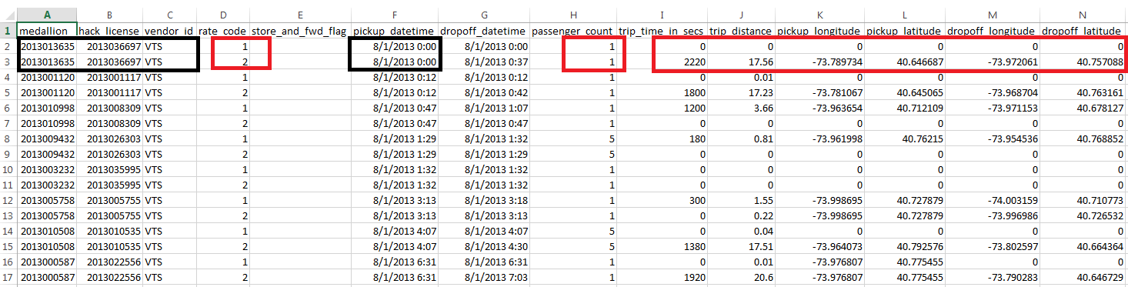

There are 503 such records in just 1 week of data.

The only consistent difference between these records is the ‘ ***rate_code*** ‘.